Hands-On Exercises - Java Fundamentals

**Setup Instructions:**

1. Create a new workspace - “Assignments” in Spring Tool Suite IDE.
2. Create a new Java Project.
3. Create your classes in the default package.
4. Define your classes as given below for each assignment.

Assignment 01

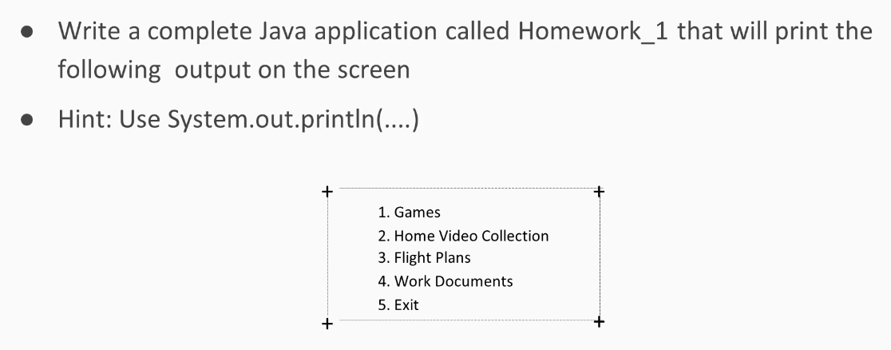

Output

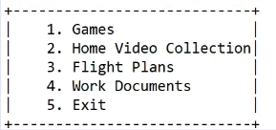

Assignment 02

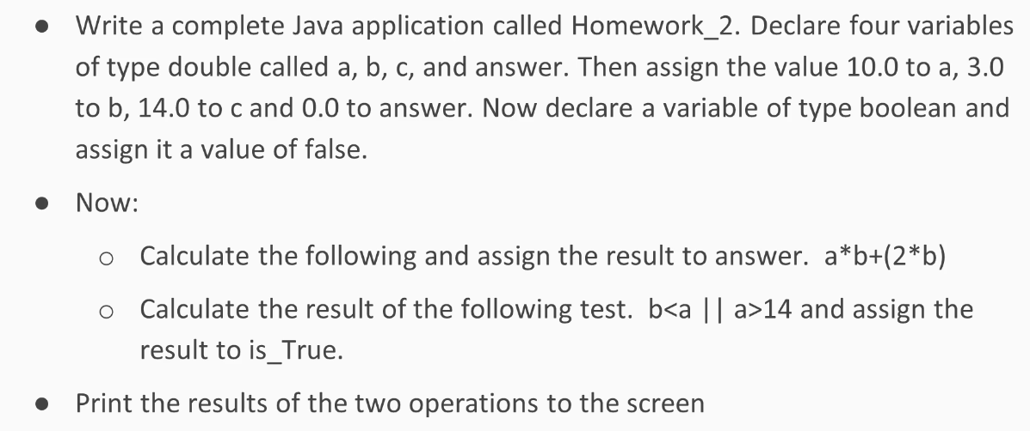

Output

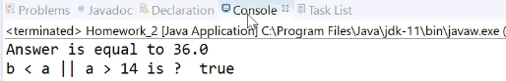

Assignment 03

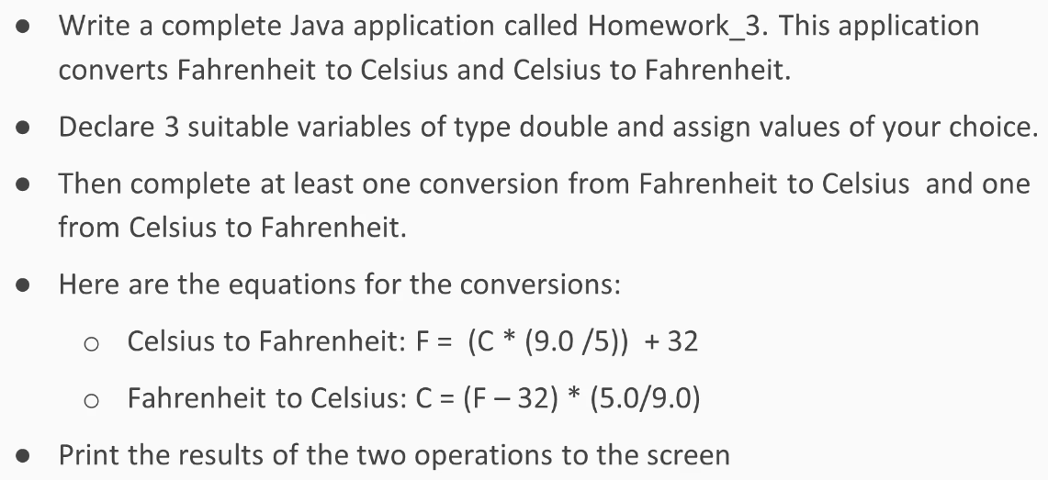

Output

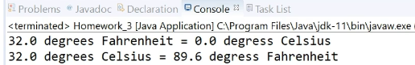

Assignment 04

Create the following class to test an array of primitive type double and an array of String objects.



